





INITIAL
ASSESSMENT
REPORT

DATE: 13th May 2024
Marketing –
Digital Marketing,
Digital Business,
Marketing (Branding & Customer Testimonials)

VERSION: 1.0

Document History
Document version | Remarks | Submitted  By | Submission  Date | Approved BY | Approval  Date
1.0 | First Draft | k&S Digiprotect | 13th May 2024

K&S Digiprotect Services Pvt. Ltd.
Date of Discussion: Date of Release:
Version: 1.0
Date of Release: 15th April 2024

Table of Contents
Introduction 4
Objectives 4
General Information 5
SPOC Information 5
Department Hierarchy* 6
Key Processes 7
Data Flow Diagram (DFD) 9
Data Mapping and Inventory 10
Recommendations 12
Action Plan 12
Requirements 12
Conclusion 13
Appendices 13
Appendix A 13

Introduction
Digital Marketing Department in ISFC crafts strategic campaigns to enhance brand visibility and engage target audiences effectively. They optimize online channels through data-driven approaches to drive customer acquisition and play a key role in this.
The Digital Business Department scrutinizes the lead quality, through a rigorous assessment criteria and manual checklist-based process, sifting through leads with precision, ensuring that each prospect meets the standards before they are transferred further into the sales funnel. This meticulous approach aims to enhance the conversion rate, maximizing the return on investment on marketing endeavours.
The emphasis on branding goes beyond mere visibility; it ensures a commitment to excellence and customer satisfaction. Through compelling storytelling and consistent messaging, they cultivate a distinct brand identity that resonates with their target audience. Leveraging customer testimonials, they showcase real-life experiences that highlight the value and trustworthiness of ISFC’s services, establishing credibility.
This report encapsulates critical insights derived from an extensive interview conducted with the Marketing Department including Digital marketing, Digital business, branding, and customer testimonials, of India Shelter Finance Corporation Limited (ISFC) for compliance with the Digital Personal Data Protection Act (DPDPA) and the implementation of ISO/IEC 27001:2022.
The overarching objectives of this interview were dual fold: first, to gain an understanding of the departmental structure, and second, to delve into the core operational processes of this department. Additionally, the interview aimed to assess the existing information security practices, focusing on adherence to DPDPA requirements, and evaluating the readiness for ISO 27001:2022 implementation.
By delving into the details of the department's organizational setup, operational workflows, and data handling procedures, this report endeavours to identify both the strengths and areas of improvement in DPDPA compliance and information security management within the department.

Objectives
- Understand the departmental hierarchy and reporting structure.
- Learn the existing processes of ISFC’s Digital Marketing, Digital Business, and Marketing (Branding & Customer Testimonials) Departments.
- Mapping of existing processes with documented processes.
- Offer recommendations to optimize the existing processes.

General Information
Organization Name | India Shelter Finance Corporation Limited
Department Name | Digital Marketing  Digital Business  Marketing (Branding & Customer Testimonials)
Date of the Assessment | Digital Marketing & Digital Business - 24th April 2024  Marketing (Branding & Customer Testimonials) - 26th April 2024
Location | 3rd Floor, 6th Floor, India Shelter HQ, Gurugram
Meeting Duration | Digital Marketing & Digital Business – 1 hr  Marketing (Branding & Customer Testimonials) - 30 minutes
Attendees (ISFC) | Siddharth Bhargava, Sachin Yadav, Ankita Mahajan, Dheeraj Yadav, Sunil Kumar Sharma
Attendees (Digiprotect) | Lalit Mohan Joshi, Sushil Menon, Adhita Razdan

SPOC Information
Project SPOC: Dheeraj Yadav
Contact Information:
Email ID: dheeraj.yadav@indiashelter.in

Project Coordinator: Sunil Kumar Sharma
Contact Information:
Email ID: sunil.sharma2@indiashelter.in

Department SPOC:
- Digital Marketing – Siddharth Bhargava
- Digital Business – Sachin Yadav
- Marketing (Branding & Customer Testimonials) – Ankita Mahajan
Contact Information:
Email IDs:
- Siddharth Bhargava: siddharth.bhargava@indiashelter.in
- Sachin Yadav: sachin.yadav1@indiashelter.in
- Ankita Mahajan: ankita.mahajan@indiashelter.in

Department Hierarchy*

* As informed during the meeting

Key Processes
S. No | Key Activities | Observations and Asks | Remarks
 | Marketing through Digital Partners and Channels  - Online lead generation is done through partners such as Facebook, Home Credit, Bajaj Marketplace, Credit Mantri, etc.  - These platforms also provide analytics data on the leads generated including demographics, and responsiveness of digital campaigns. | - ISFC to confirm if the digital partners retain lead data, and the time period of retention. | - Contracts with lead generation platforms should have clearly defined roles in terms of Data Fiduciary and Data processor.  - Data retention period clause to be added in contracts.
 | Campaign Management  - Digital marketing campaigns are created and managed across various platforms such as Google Ads, Meta, etc.  - Continuous optimization of campaigns based on performance metrics is also done inhouse.  - The leads generated through these platforms are transferred to Digital Business department.  - Marketing department also organizes events for generating leads which are further connected to Digital Business. | NA
 | Lead Conversion  - Leads undergo rigorous checks by Digital Business based on a predefined checklist.  - Filtering is done to determine policy fit according to ISFC's Loan Policy.  - Qualified leads interested in loans are transferred to respective branches.  - Branch managers and loan officers receive SMS notifications and calls with customer details. | - Calling script shared by ISFC has PII (mobile number).  - Responses on negative answers not recorded in calling script.  - All Loan Officers have their personal mobiles and numbers.
 | Lead Follow-up  - Engaging with leads through targeted communication and follow-up to guide them through the loan application process and address any inquiries or concerns. | NA | - Explicit consent to be taken prior to contacting leads.  - ISFC to also ensure that their Digital Partners also take prior consent.
 | Analytics on Leads Generated  - Analysing raw data to understand the performance of different partners in generating high-quality leads. | NA | - Analytics is done on raw data of leads. ISFC to explain business case for the same.
 | Customer Testimonials  - Digital Marketing also takes care of Customer Testimonials.  - All videography is done in-house by ISFC.  - The videos are stored in memory cards as well as on One Drive.  - Consent is taken from all customers prior to filming them for the testimonial.  - Consent is stored in One drive in scanned format. | NA | - ISFC to share customer consent form.  - Data retention for customer testimonial videos to be defined by ISFC.
 | Social Media Advertising  - Planning and executing advertising campaigns on social media platforms such as Facebook, Instagram, LinkedIn, and Twitter.  - Targeting specific audience segments, creating ad creatives, and monitoring campaign performance to achieve marketing objectives. | NA | - ISFC to explain process of demographic identification on social media platforms.
 | Content Creation and Management  - All content for marketing and branding is created in-house by the digital marketing team. | NA

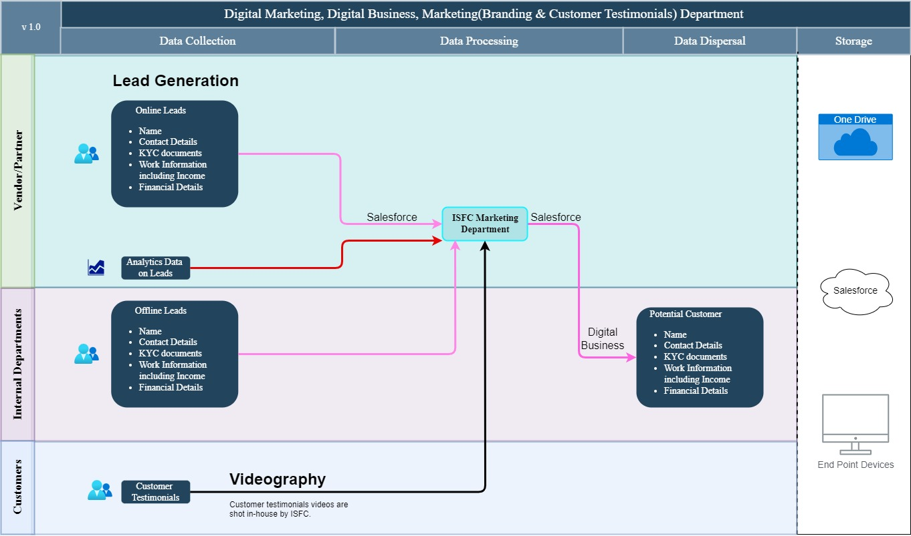
Data Flow Diagram (DFD)

Data Mapping and Inventory
S. No | Data Category | Description | Purpose | Data Owner | Storage Location | Data Classification* | Retention Period | Legal Obligation
1. | Customer Contact Details | Contact information of customers including phone and email | Communication and marketing efforts | Digital Business | Salesforce | PII/  Sensitive | Not Defined | Consent
2. | Marketing Campaign Data | Data related to marketing campaigns (analytics data – channels, ad views, bounce rate, etc.) | Assess campaign effectiveness | Digital Marketing | Salesforce | Non - PII/  Non-Sensitive | Not Defined | NA
3. | Social Media Interactions | Interactions and engagements on social media platforms | Engage with audience and analyse trends | Digital Marketing | Social Media Channels | PII/  Non-Sensitive | Not Defined | Legitimate interest
4. | Customer Testimonials | Feedback and opinions provided by customers | Measure customer satisfaction | Digital Marketing | Memory Cards / One Drive | PII/Sensitive | Not Defined | Consent
5. | Lead Generation Data | Information on potential leads and prospects | Identify and nurture potential customers | Digital Business | Salesforce | PII/Sensitive | Not Defined | Consent
6. | Email Marketing Lists | Lists of email subscribers and recipients | Send targeted marketing communications | Digital Marketing | Salesforce | PII/Sensitive | Until unsubscribed | Consent
7. | Market Research Reports | Reports and findings from market research activities | Understand market trends and preferences | Digital Business | One Drive | Non-PII/  Public | As required | NA
8. | Advertising Contracts | Contracts and agreements with advertising partners | Manage advertising partnerships | Digital Marketing | One Drive | Non-PII/  Confidential | As per contract terms | Contractual necessity
9. | Demographic Data | Information about customers' demographics such as age, gender, etc. | Target marketing campaigns | Digital Marketing | Salesforce | Non -PII/  Sensitive | Not Defined | NA
10. | Ad Performance Metrics | Metrics related to the performance of advertisements | Evaluate ad effectiveness and ROI | Digital Marketing | Salesforce/  One Drive/ End point devices | Non-PII/  Confidential | As required | NA
11. | Market Segmentation Data | Data used to segment the market based on various criteria | Target specific audience segments | Digital Marketing | Salesforce | Non -PII/  Private | As required | NA
*Refer Appendix A

Recommendations
- Due Diligence of Digital Partners:
- Conduct due diligence on all digital partners to ensure compliance with ISFC’s information security, and data privacy standards.
- Establish data processing agreements (DPAs) with digital partners to clearly define roles, responsibilities, and data protection obligations.
- Regularly review and assess the security measures and data handling practices of digital partners to mitigate risks of data breaches.

- Campaign Management:
- Encrypt sensitive data related to campaign management, such as lead information, during transmission and storage to protect against unauthorized access/modification.
- Conduct regular security assessments and audits of campaign management systems to identify and address vulnerabilities and compliance gaps.

- Analytics on Leads Generated:
- Anonymize lead data wherever possible to reduce the risk of unauthorized disclosure of personally identifiable information (PII).
- Data Retention policies need to be created and implemented to ensure that analytics data on leads is retained for only as long as necessary and securely disposed of when no longer needed.

- Lead Conversion:
- Conduct regular training and awareness programs for staff involved in lead conversion to ensure compliance with DPDPA requirements for data protection and privacy.
- Loan Officers on ground contacting potential and existing customers may explain the types of personal data collected, and the purpose for the same.

- Customer Testimonials:
- Implement encryption and access controls to protect customer testimonial videos stored on memory cards and OneDrive from unauthorized modification.

Action Plan

Requirements
- Customer Consent Form (taken prior to videography for testimonials)

Conclusion
In conclusion, by leveraging encryption technologies, ISFC’s Marketing Department (Digital marketing, Digital business, branding, and customer testimonials) can fortify sensitive information against unauthorized access, interception, or interference, ensuring compliance with the Indian data protection regulation, DPDPA.
Employing consent mechanism and privacy notices will further strengthen the department's commitment to respecting individual privacy rights. By obtaining explicit consent from customers and providing transparent privacy notices outlining data processing activities, purposes, and rights, the department fosters trust and accountability in its data handling practices.
Continuous training and awareness initiatives will also be vital in empowering employees with the knowledge and skills needed to navigate privacy regulations effectively. Regular monitoring and review of procedures will ensure the ongoing effectiveness of encryption measures, enabling prompt adaptation to evolving security threats.

Appendices

Appendix A
Data Classification | Definition
Sensitive Data | Information that, if disclosed, altered, or destroyed without authorization, could cause significant harm to an individual, organization, or entity. This often includes financial records, medical information, and PII.
Restricted Data | Highly sensitive data tightly controlled due to legal, regulatory, or contractual requirements. Access is limited to authorized personnel, and any unauthorized disclosure may result in severe consequences.
Private Data | Information considered confidential and intended solely for specific individuals or groups within an organization. It requires protection from unauthorized access to maintain privacy and uphold confidentiality agreements.
Confidential Data | Privileged or proprietary information of an organization requiring protection from unauthorized access, disclosure, or alteration.
Public Data | Information that is freely available and accessible to the general public without restrictions or limitations. It does not contain sensitive or confidential information and can be openly accessed and used for various purposes such as research, analysis, and public interest initiatives.
PII (Personally Identifiable Information) | Data that can identify, contact, or locate an individual, either alone or in combination with other information. For example - names, addresses, official identifiers (Aadhar, Pan, DL, biometrics, etc).
Non-PII | Data that, while not personally identifiable, however may still require protection due to its sensitivity or confidentiality. This may include corporate financial information, proprietary research data, or internal communications.

-----------------------------------End of Report for Digital Marketing, Digital Business,
Marketing (Branding & Customer Testimonials) Department---------------------------

